Drumbeats Bring Therapeutic Rhythm to Veterans’ Lives
By Bill Armstrong, Public Affairs Specialist, New Mexico VA Health Care System

A group of five psychiatric patients recently sat in a circle within Ward 7 of the Raymond G. Murphy VA Medical Center in Albuquerque, N.M. The veterans slapped their hands on synthetic heads of African-style drums, tapped wooden sticks together and shook egg-shaped percussion instruments to keep their rhythmic session going. This active music-making experience was part of a new therapy program at the facility, led by Giselle Felicia Vivian, an Albuquerque-based drum circle facilitator and music therapy consultant. Vivian’s participants often have never beaten a drum before, but experience is not required.
“At first, everyone is getting connected to the instrument, and the instrument is the vehicle for that sense of neurology and biology phasing itself to a more peaceful, focused, simple rhythm,” Vivian said. “From that level, there’s this very organic thing that happens in the group. You’ll observe it the longer people drum together. It is as if you are trying to put a peg in the hole. There’s a magical moment when all of a sudden – WHOOSH – it just kind of drops in. At that moment, the rapport has happened and the group now is one. And from that place, they start to unleash a more empowered level of creativity and self expression.”

Vivian and all of the instruments come courtesy of a Department of Veterans Affairs grant secured by Nan Gile, Recreation Therapist with the medical center’s Stroke and Rehabilitation Service. The grant funds two of Vivian’s therapeutic drumming sessions per month for six months, ending in late December.

The therapeutic drumming already seems to be working for the patients who chose to attend the sessions.

“In the last group we had, there was a gentleman who wasn’t making any contact at all. He was in kind of a drowsy place most of the time. But at the end of the drumming group, he became so lucid and so articulate,” Gile said.

That transformation is a program goal. According to Vivian, music therapy sessions like this are designed to promote wellness, manage stress, alleviate pain, express feelings, enhance memory, improve communication and promote physical rehabilitation.

One veteran stopped beating his drum for a moment to raise both arms in the air and shout. This emotional release is just one of the benefits that Vivian has witnessed within the group.

“The drum is an extension of our voice. Sometimes we can talk about how we’re feeling, and sometimes we let the drum do our talking,” Vivian said.

At the end of a session, Vivian asks the patients to close their eyes, take a deep breath and imagine they are standing firmly on the ground. Feedback from the patients has been positive. As he was walking out, an older Veteran told Vivian the therapy helped remove his tension and served as a good distraction from his problems.

“Some of the patients leave with smiles on their faces – just real upbeat,” Vivian said.

As the drum circle facilitator, Vivian is training Gile to continue the therapy sessions after the grant ends. Gile is working with other medical center staff in an effort to expand music therapy sessions to other wards to help more veterans discover the common language of the drum beat and its benefits.
###

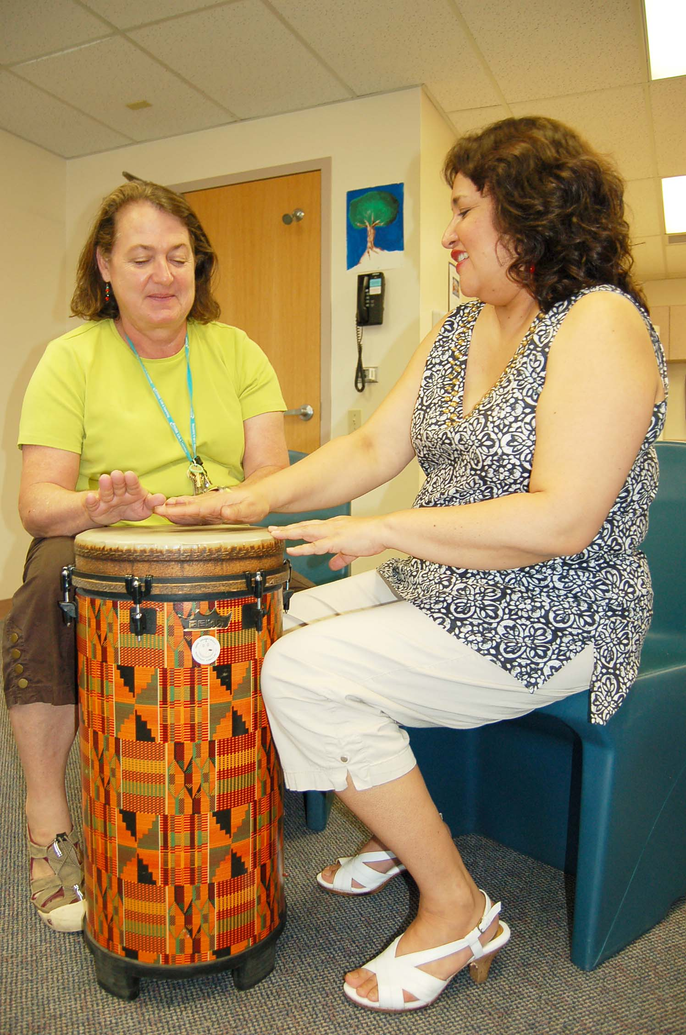
DrumLesson2: Nan Gile (left), a VA recreation therapist, practices her beat pattern during a training session with Giselle Felicia Vivian, an Albuquerque-based drum circle facilitator and music therapy consultant.

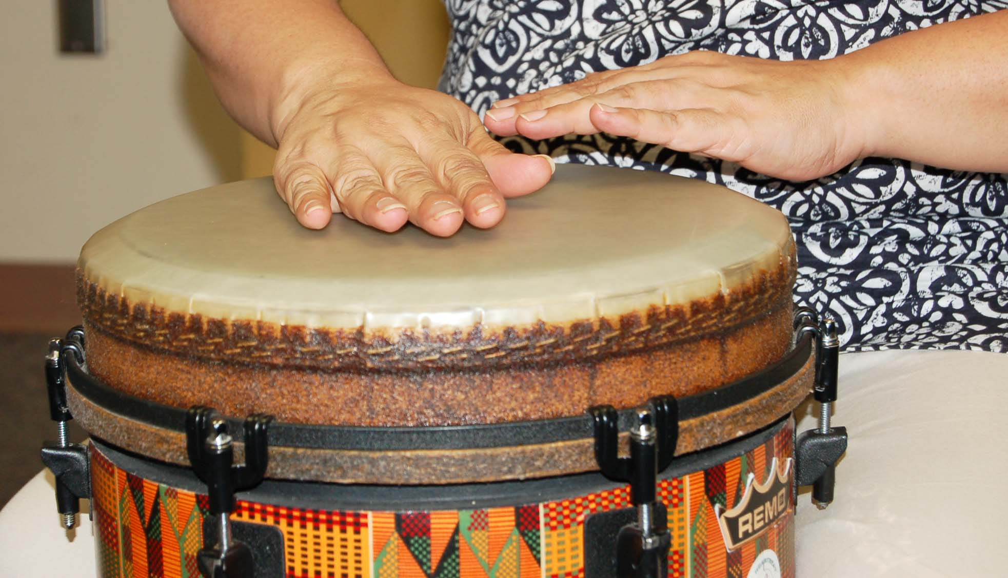
Drumming: Therapy sessions like this are designed to promote wellness, manage stress, alleviate pain, express feelings, enhance memory, improve communication and promote physical rehabilitation.

