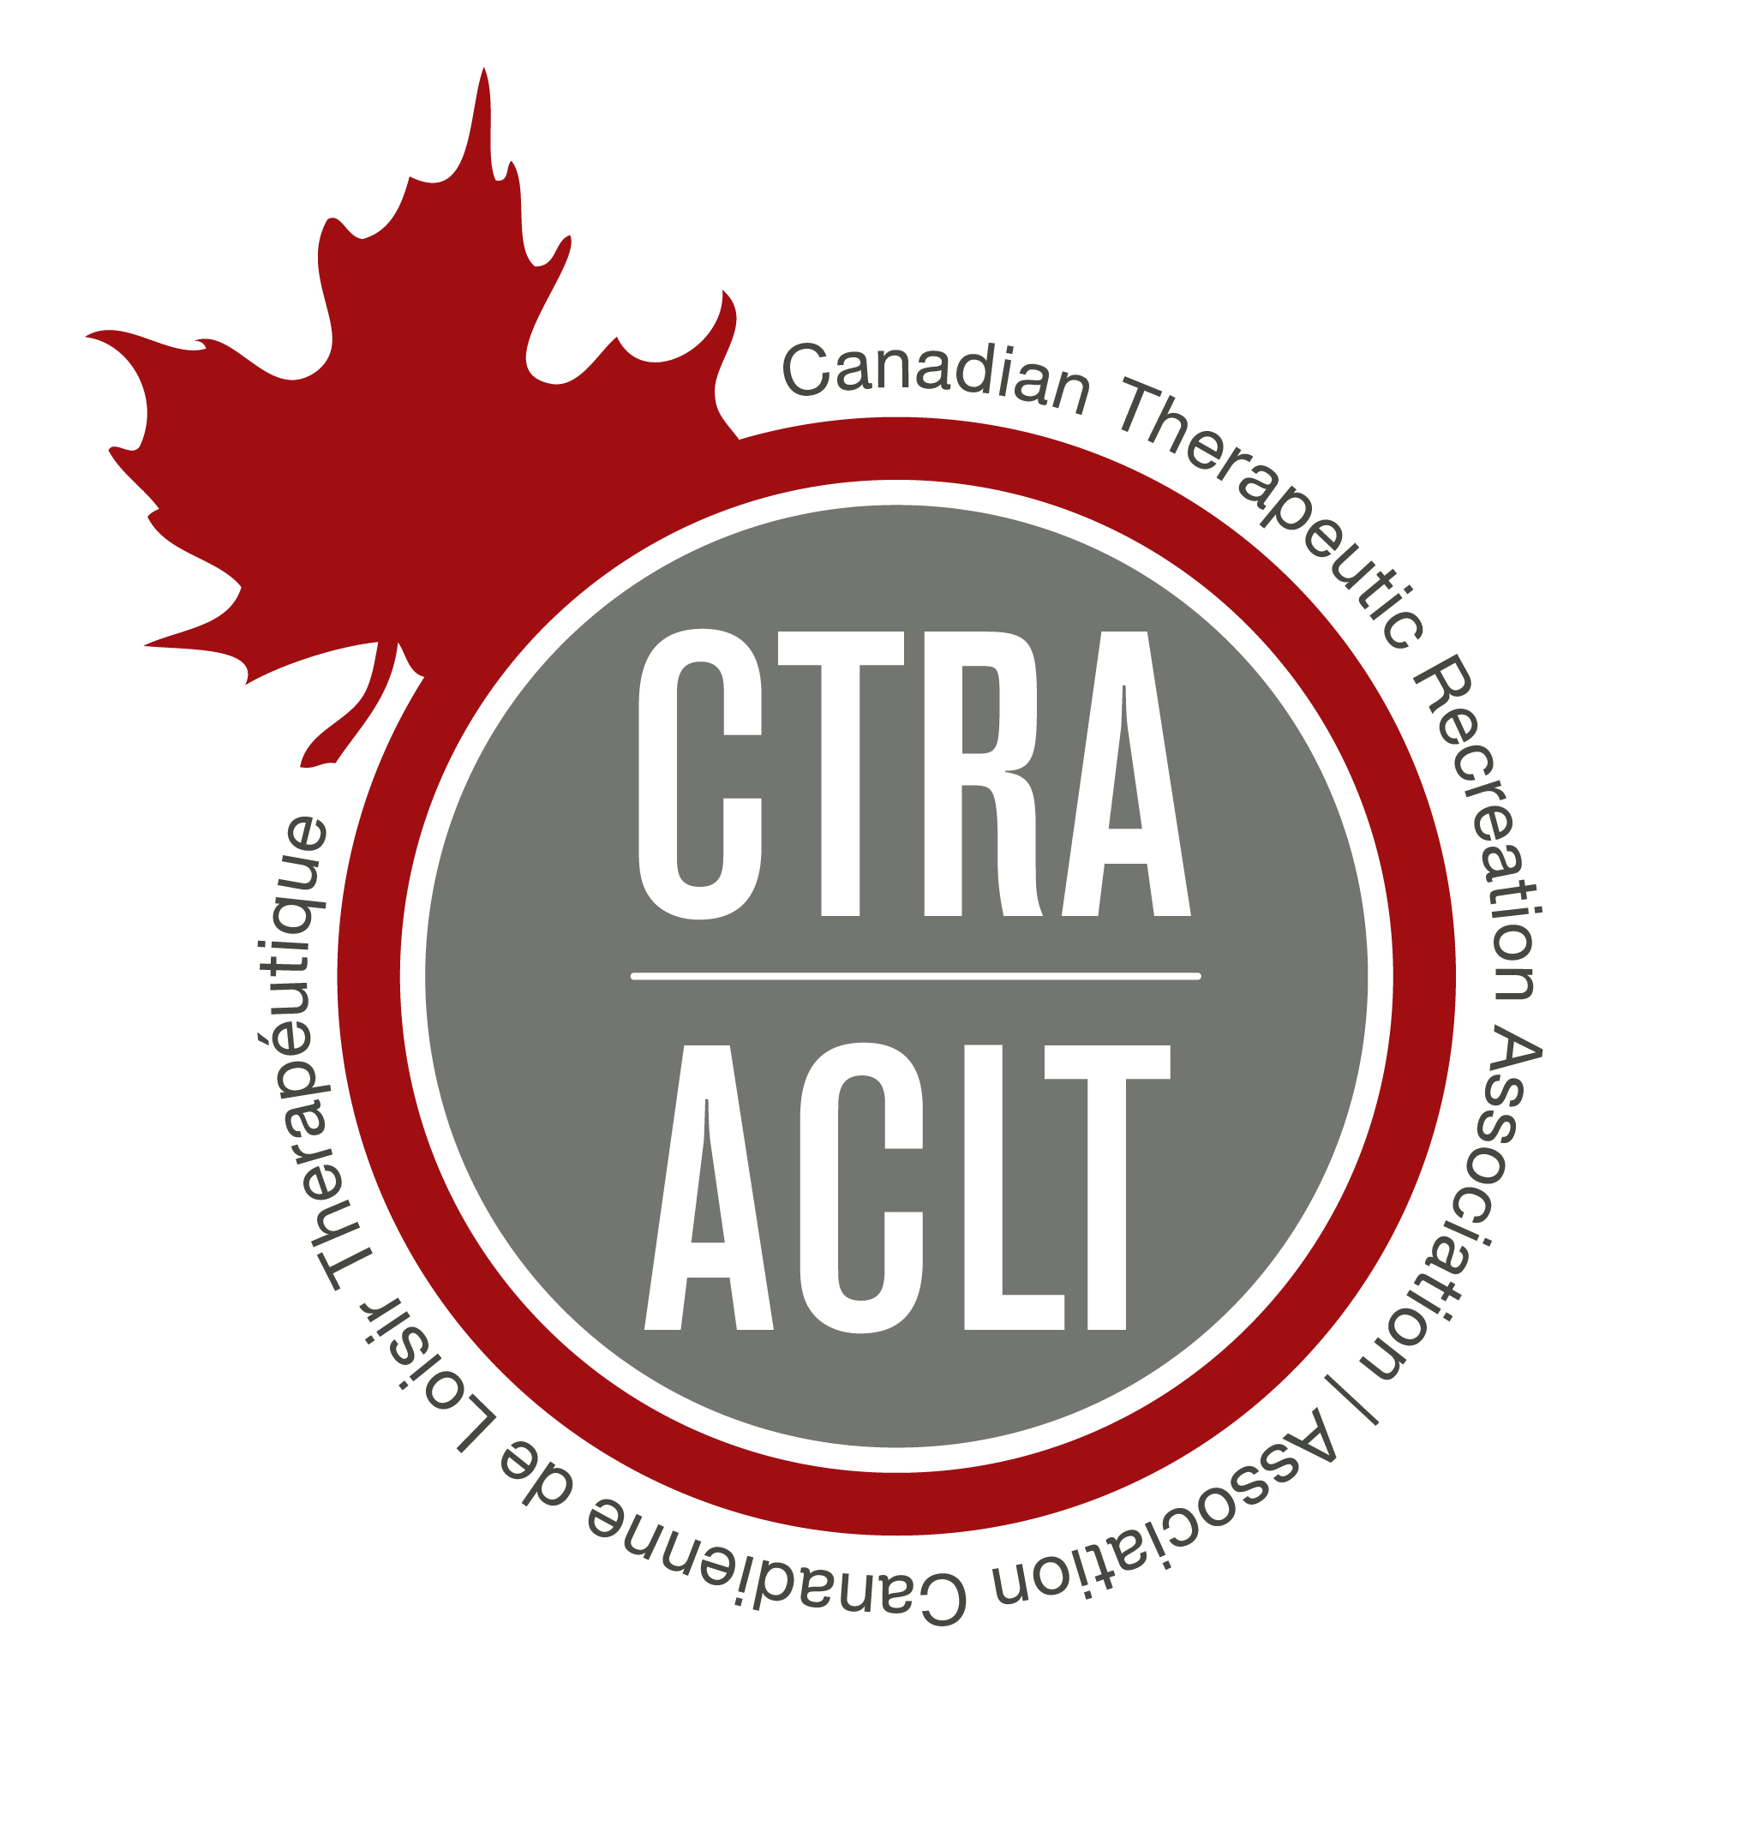

Securing Our Future in Health and Wellness
CTRA 16th Annual Conference
Call for Presentations

TITLE OF SESSION: Limit 65 characters typed exactly as it will appear in the program
PRESENTATION FORMAT:
Pre-conference Session: Half-day intensive (3.5 hours), or a full-day intensive
(7 hours)
Workshop: Presentation including facilitative discussion (60 or 90 minutes)
Panel Discussion: Examination of specific topic/issue-1 facilitator and ___ panel
members-specify (60 or 90 minutes)
Lecture: Educational presentation with questions and answer time at the end
(60 or 90 minutes)
Research: 25-minute presentation with 5-minute question and answer time at
the end (30 minutes)
Interactive: Experiential, participatory, facilitative (60 or 90 minutes)
Poster: 4’ X 6’ visual display of completed research, works in progress, case studies, & TR program interventions

Length of session: 30 min (Research Only) 60 min 90 min
Half-Day (3.5 hrs) Full Day (7.5 hrs)

PROGRAM DESCRIPTION: Limit to 50 words (to be included in final program.)

PROGRAM LEARNING OBJECTIVES: Include 2007 NCTRC Job Analysis Professional Knowledge codes (FLW – Foundational Knowledge, PTR – Practice of TR/RT, ORG – Organization of TR/RT, ADV – Advancement of the Profession).
Please Note: Objectives must be measurable or application is incomplete. An example of a measurable objective is as follows: “Upon completion of this session, each participant will be able to list at least 3 professional competencies needed to practice successfully within the TR profession.”

Code: |  | Objective:
Code: |  | Objective:
Code: |  | Objective:

NCTRC Specialization Area(s) (cHECK ALL THAT APPLY)
Geriatrics Physical Medicine/Rehabilitation Behavioral Health
Community Inclusion Services Developmental Disabilities

Target Audience: Student TR Practitioner Supervisor Researcher/Educator
Language: English French (Presentations will be made in the language of the proposal).

AUDIO-VISUAL EQUIPMENT: Please check all that apply. Other equipment must be provided by the presenter
Internet Access Audio for Computer Computer & LCD Projector Speaker to provide their own Computer

ROOM ARRANGEMENT PREFERRED: Specify theatre style or open area for experiential. Room set-ups may be limited due to logistics.

ADDITIONAL REQUESTS OR SPECIAL NEEDS:. (List any special requests you may have for your presentation (e.g., set up time needed, noise volume of presentation, ideal time or day, room arrangement, activity space required, additional supply fees if any, limit to the number of participants, etc.) Please note: These will be considered by CTRA but not guaranteed.

FOR RESEARCH PRESENTATIONS: ABSTRACT OF SESSION: Limited to 500 words.

SPEAKER INFORMATION
Please include information for all speakers who will be presenting your session.
Use additional paper if needed. Confirmation of session acceptance and all
correspondence will be sent to the primary speaker listed below.

Speaker(s): Names will be printed in program brochure in order listed here.
Name & Credentials |  | Job Title/ Agency | Agency Address | Work Phone | Email
1

2
3
4

REFERENCES FOR EACH SPEAKER:
Speaker | Reference Name | E-Mail | Phone
Speaker | Reference Name | E-Mail | Phone

BIOGRAPHY OF PRIMARY SPEAKER: (This biography will be used for the conference program)

BIOGRAPHY OF ADDITIONAL SPEAKERS: (This biography will be used for the conference program)

A current professional resume (maximum of one page) must be submitted along with the Application Form.

Please note submission of a PDF file of your presentation must be received 14 days prior to the conference.

For office use only:
Date received: Accepted: Yes No
Session #: Day:
Time:
Type of Presentation: Pre-conference Workshop Panel Lecture
Research Interactive Poster
Confirmation Sent:
Agreement Returned:

Conference Co-Hosts



